Stat 587, section 2 – Lab 12
Goals: In this lab, we will see how to:
calculate the PRESS statistic to quantify “out of sample” prediction error
fit regression models to all subsets of variables

To calculate the PRESS statistic:
- Fit a model. Then, click the red triangle for that model, select Row Diagnostics, then select Press.
- A small output box, labelled Press, with two numbers is included with the output.
The Press number is a Sum-of-Squares; the Press RMSE is a standard deviation.

To fit regression models with all subsets of variables:
This uses the SAT example from lecture and Chapter 12 case study. The data are in sat.xlsx. This file excludes Alaska (unusual in many ways) and includes ltakers, a column for log(takers). The goal is to determine which state characteristics best predict SAT score.

The question is ‘which variables?’. To answer this:
- Analyze / Fit Model. Select SAT as the Y variable and income, years, public, expend, rank, takers and ltakers as X variables. In other words, all other variables except for state.
- Look for the Personality box (top right of the Fit Model dialog). It shows Standard Least Squares by default. Left click on that and change the Personality to Stepwise. The Fit Model dialog should look like:

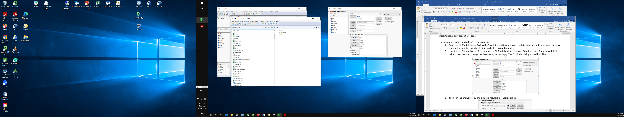

- Then run the analysis. You should get a results box that looks like:
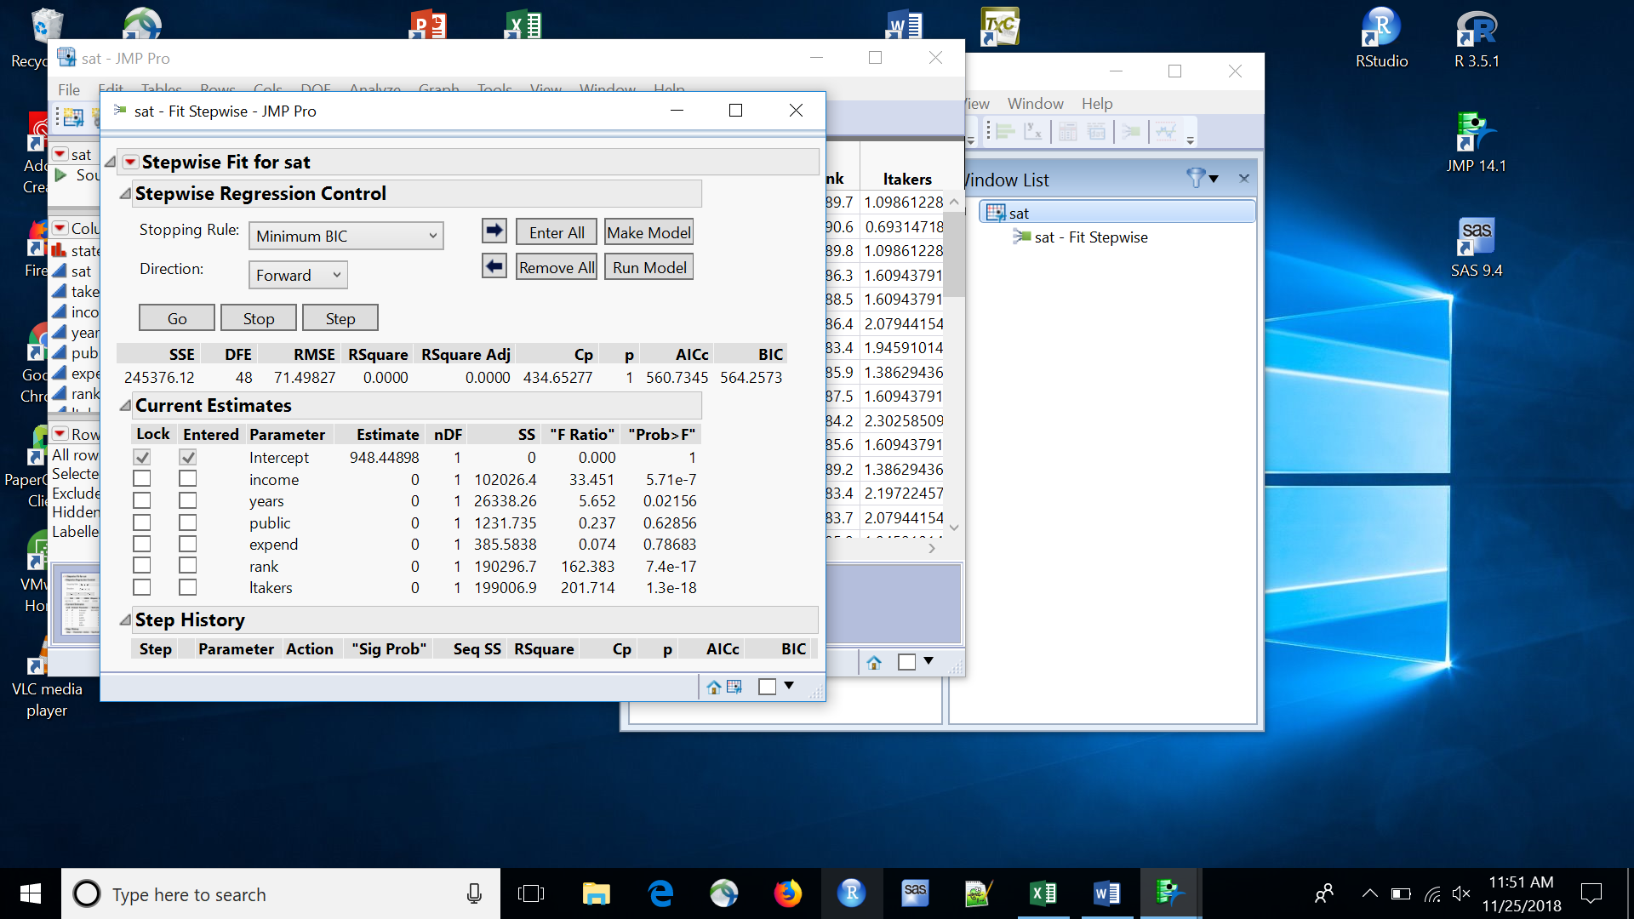
- Click on the red triangle at the top left (by Stepwise Fit), and left click on All Possible Models
- You will get a dialog box that helps you limit the number of models that see results from. JMP will fit all possible models; you don’t want to see results from all of them. You can limit the number of variables that can go in the model. Here JMP supplies 7, the number of X variables. That’s reasonable. You can also see how many models you want to see for each number of variables. This is the number of one-variable models, the number of two-variable models, … up to the number of 7 variable models. The default depends on the number of X variables. For this data set, JMP suggests 35 results per number of variables, which here would give you results for all possible models. If that’s more than you want to see, you change the 35 to a smaller number. I chose 10. If you decide later that you want to see more models, you can always rerun with a larger number. Then click OK.
Notes:
1) The choice of 15, 10, 5 or 4 is a display option. JMP will fit all models. For 7 variables, that is 128 models.
The choices in the menu box only control how much you see. You don’t want to see results for all models!
2) The dialog box has a checkbox to enforce hierarchy. Enforcing hierarchy means that if an interaction term is included in the model, so are its component effects. So, if A*B is in the model, so are A and B. Not enforcing hierarchy means that A*B can be in the model without A and B. General advice is to enforce hierarchy unless you know what you are doing and have specific reasons not to. If you have interactions or polynomial terms, you probably want to check the box. If you don’t have any interactions or polynomial terms (the situation here), this option has no effect.
- The results look like (only the top of the table):
- 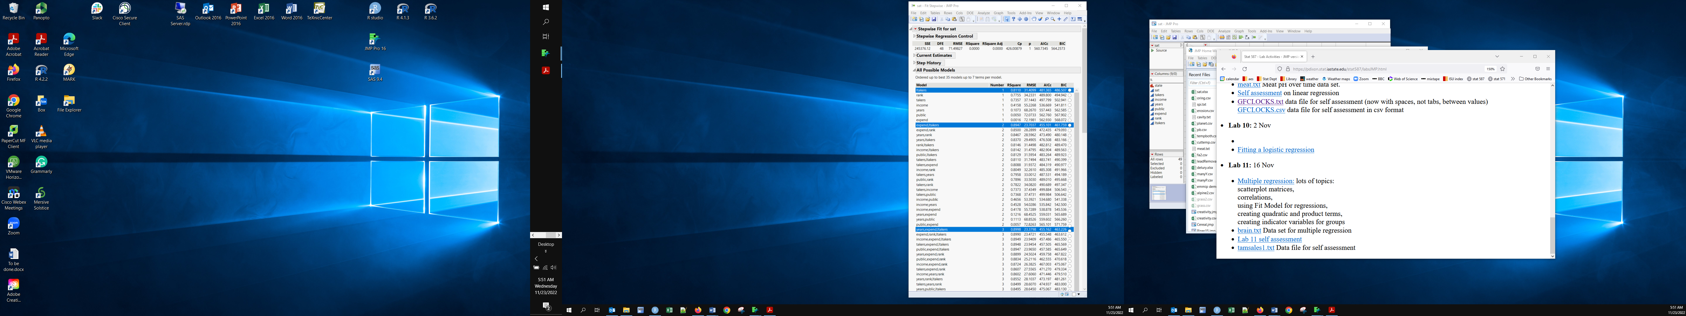

- You see that JMP is giving you model summary statistics for 7 one-variable models, then 21 two-variable models, and so on. If you provided 4 models per model size in step 5, you would only get the best 4 one-variable models, then the best 4 two-variable models, etc. The blue highlights indicate the best one-variable, the best two-variable, etc. models.
- It is useful to sort this table by increasing value of the AICc statistic (so the model with the smallest AICc is at the top, the second smallest is next, and so on). AICc is a small sample adjusted version of AIC (the extra c is ‘corrected’, we haven’t talked about the details. AICc has the same properties and interpreted the same way). To sort it, right-click in the table, select Sort by Column, select the AICc column, check Ascending, then OK. Why check Ascending? We want the smallest AICc value at the top. That’s sorting from smallest to largest, i.e. ascending. The table will now look like:

Note: It is very easy to overlook and forget the Ascending option. It is a very good idea to check that the model at the top has the smallest AICc (or BIC, if that was the sort criterion) value.
- The blue highlighted models are the best within each number of variables. The best model (smallest AICc) has four X variables: years, expend, rank, and ltakers. The next best model is the five variable model with income, years, expend, rank and ltakers. Those are the only two models within 2 AICc units of the top. (You have to do that calculation yourself)
- If you want to sort by BIC, go back to step 8 and select the BIC column and check ascending.
- You can see the estimated parameters for any of these models by clicking the button on the far right of the table, then looking at the Current Estimates box (at the top of the Stepwise Fit output box).

To explore a model that looks interesting:
- You can very quickly get more information about any of the models shown in the Stepwise Fit output box. Here we look further at the top AICc model (years, expend, rank, and ltakers). Select the button next to the desired model, then look at the top of the Stepwise Fit output box:
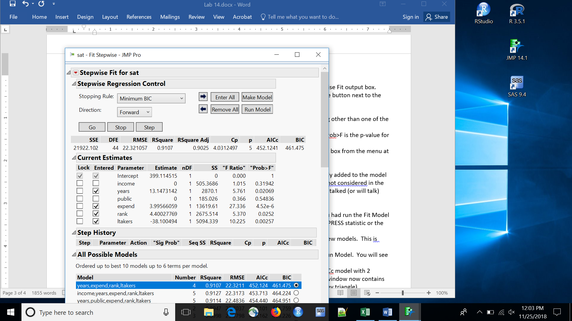
- The first line of numbers gives various model fit statistics, in case you wanted something other than one of the four in the model summary table.
The next block is the parameter estimates for the variables in the desired model. The Prob>F is the p-value for the test of whether that coefficient = 0. Some of these p-values may be > 0.05 because minimum AICc is a different criterion than p < 0.05.
- To get more information about your model, select either the Run Model or Make Model box from the menu at the very top right of the Stepwise Fit box (shown in the display above)

Make Model will open the Analyze / Fit Model dialog, with the specified variables already added to the model effects box. This is useful if you want to add additional variables, even some that were not considered in the all subsets selection, or change JMP options (e.g. centering polynomials). In lecture, we talked (or will talk) about why adding additional variables is useful when analyzing observational data.

Run Model will skip the Fit Model dialog and directly give you the model results as if you had run the Fit Model dialog. This is the quickest way to get additional information about the model (e.g. the PRESS or rMSEP statistics or the residual vs predicted values plot).

